**TRACING THE GROWTH OF THE GLOBAL COMMUNITY: A POPULATION FORECASTING ANALYSIS**

**COMPLETED BY:**

**V .KALAI SELVI**

**K .MONISHA**

**R .REXALINE**

**D .AKASH**

Tracing the Growth of the Global Community: A Population Forecasting Analysis

INTRODUCTION

1.1 Overview

The world’s population is more than three times larger than it was in the mid-twentieth century. The global human population reached 8.0 billion in mid-November 2022 from an estimated 2.5 billion people in 1950, adding 1 billion people since 2010 and 2 billion since 1998. The world’s population is expected to increase by nearly 2 billion persons in the next 30 years, from the current 8 billion to 9.7 billion in 2050 and could peak at nearly 10.4 billion in the mid-2080s. This dramatic growth has been driven largely by increasing numbers of people surviving to reproductive age, the gradual increase in human lifespan, increasing urbanization, and accelerating migration. Major changes in fertility rate have accompanied this growth. These trends will have far-reaching implications for generations to come.

Project Flow :

To accomplish this, we have to complete all the activities listed below,

● Define Problem / Problem Understanding

* Specify the business problem
* Business requirements
* Literature Survey
* Social or Business Impact.

● Data Collection & Extraction from Database

* Collect the dataset,
* Storing Data in DB
* Perform SQL Operations
* Connect DB with Tableau

● Data Preparation

* Prepare the Data for Visualization

● Data Visualizations

* No of Unique Visualizations

● Dashboard

* Responsive and Design of Dashboard

● Story

* No of Scenes of Story

● Performance Testing

* Amount of Data Rendered to DB
* Utilization of Data Filters o No of Calculation Fields
* No of Visualizations/ Graphs

● Web Integration

* Dashboard and Story embed with UI With Flask

● Project Demonstration & Documentation

* Record explanation Video for project end to end solution
* Project Documentation-Step by step project development procedure

Milestone 1: Define Problem / Problem Understanding

Activity 1: Specify the business problem

Activity 2: Business requirements

The business requirements for ‘Tracing the growth of global community’ includes

1. Accurate data on population growth and demographics for multiple countries and regions.
2. The ability to analyze and forecast population growth trends over a specific time period.
3. The ability to identify key factors influencing population growth and demographic changes.
4. The ability to present the data and analysis in a clear and visually appealing format, such as charts and graphs.
5. The ability to integrate the data and analysis with other relevant business information.
6. The ability to use the data and analysis to inform strategic decision-making for the company or organization

Activity 3:

A literature survey is a method of researching existing literature and studies related to a specific topic. In the context of ‘Tracing the growth of a global community’ a literature survey would involve reviewing studies and articles that have been published on the topic of population and demographics, as well as studies specific population increase in cities, The literature survey would include sources such as academic journals, industry reports, and online articles. It would aim to identify key performance indicators (KPIs)

Activity 4: Social or Business Impact.

**Social Impact:**

Improve the infrastructure and strategies through which the cities could manage the population.

**Business Model/Impact:**

Improved strategic planning: By understanding population growth trends and demographics, a business can make more informed decisions about where to invest resources and expand operations.

Milestone 2: Data Collection & Extraction from Database

Data collection is the process of gathering and measuring information on variables of interest, in an established systematic fashion that enables one to answer stated research questions, test hypotheses, and evaluate outcomes and generate insights from the data.

Activity 1: Collect the dataset Please use the link to download the dataset:

[https://drive.google.com/file/d/1NRrQhbZ8KuzpkvXl9C6MBzFrXg2sE- J6/view?usp=share_link](https://drive.google.com/file/d/1NRrQhbZ8KuzpkvXl9C6MBzFrXg2sE-%20J6/view?usp=share_link)

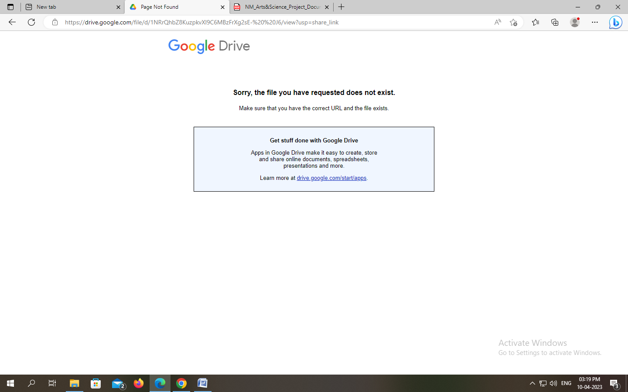

Activity 1.1: Understand the data

The data was compiled by UNSD(united nations statistics division).

To understand more about the dataset, please go through this :

<https://datahub.io/core/population-city>

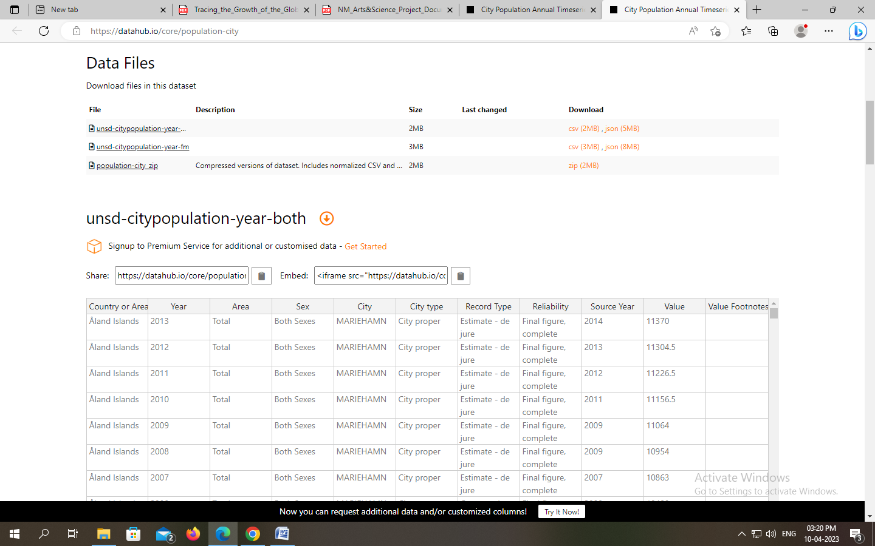

Activity 2:

Storing Data in DB & Perform SQL Operations Explanation video link: <https://drive.google.com/file/d/1uUaPt7PE3t-jPk4txwyGsbVDkcXzDwOl/view?usp=sharing>

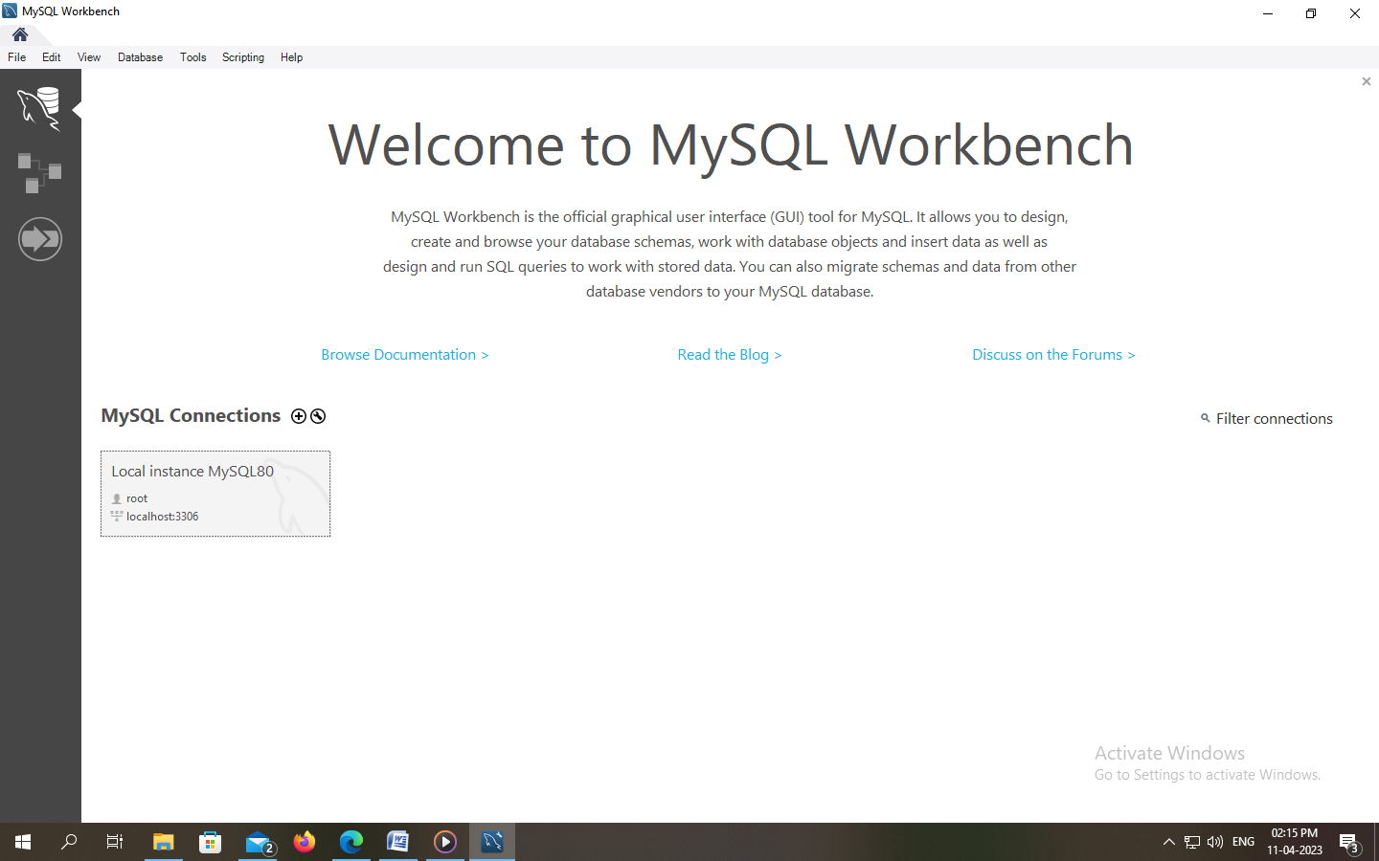

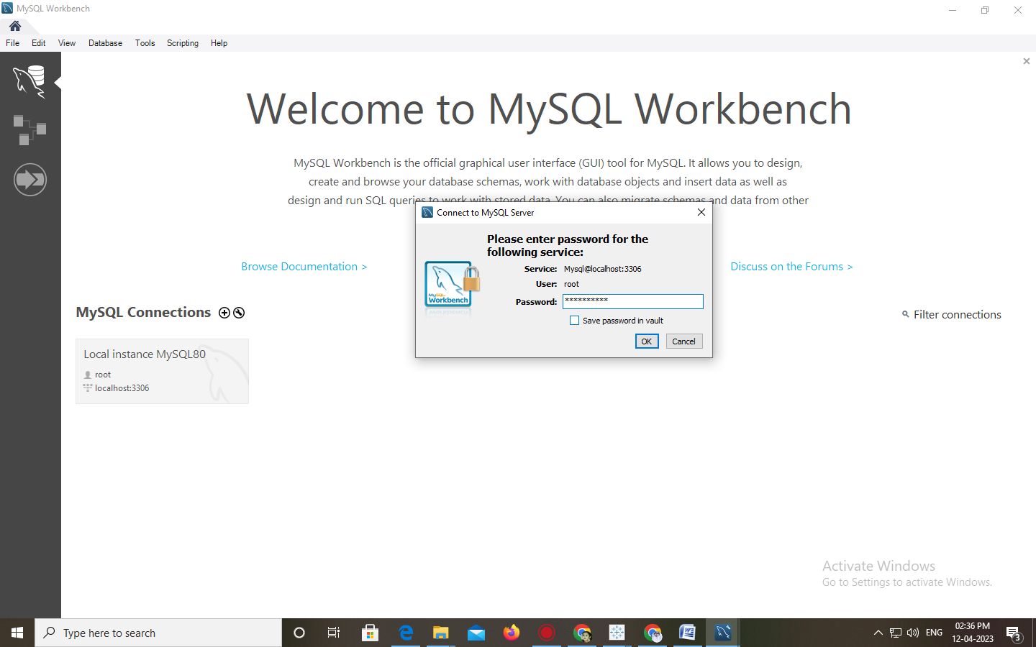

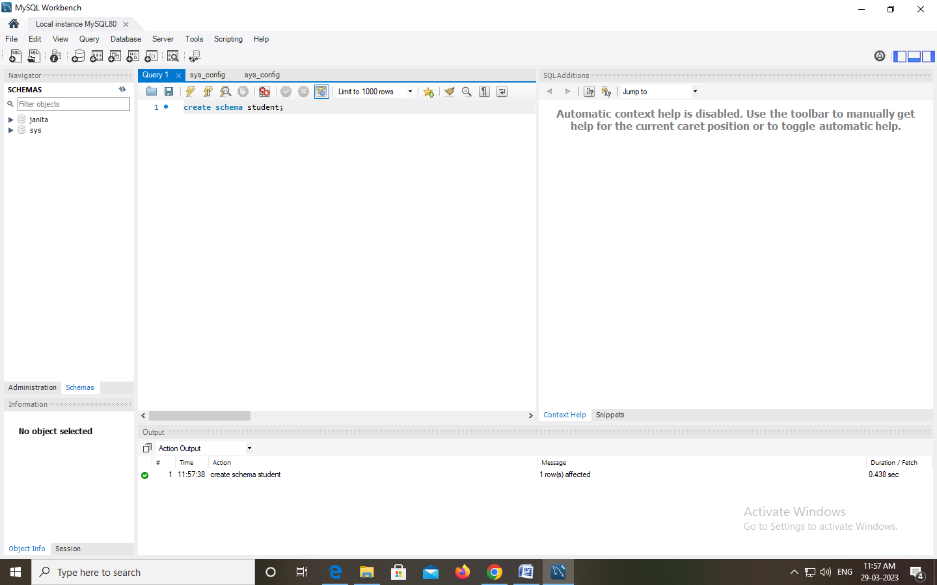

Activity 3:

Connect DB with Tableau Explanation video link:

<https://drive.google.com/file/d/11uLSwvMxLVtZdHCkvdSWfRZjriMvaQJB/view?usp=share_lin>

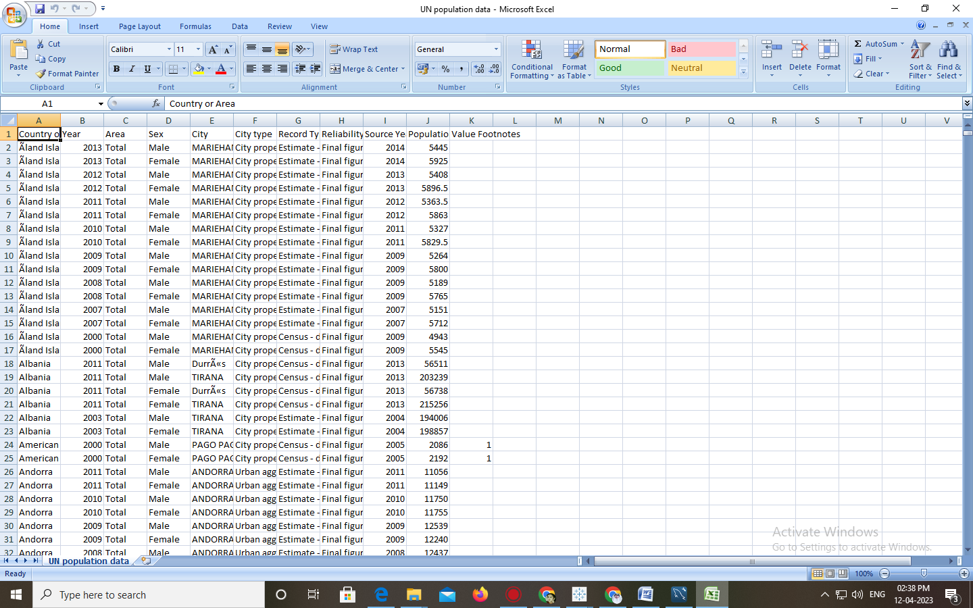

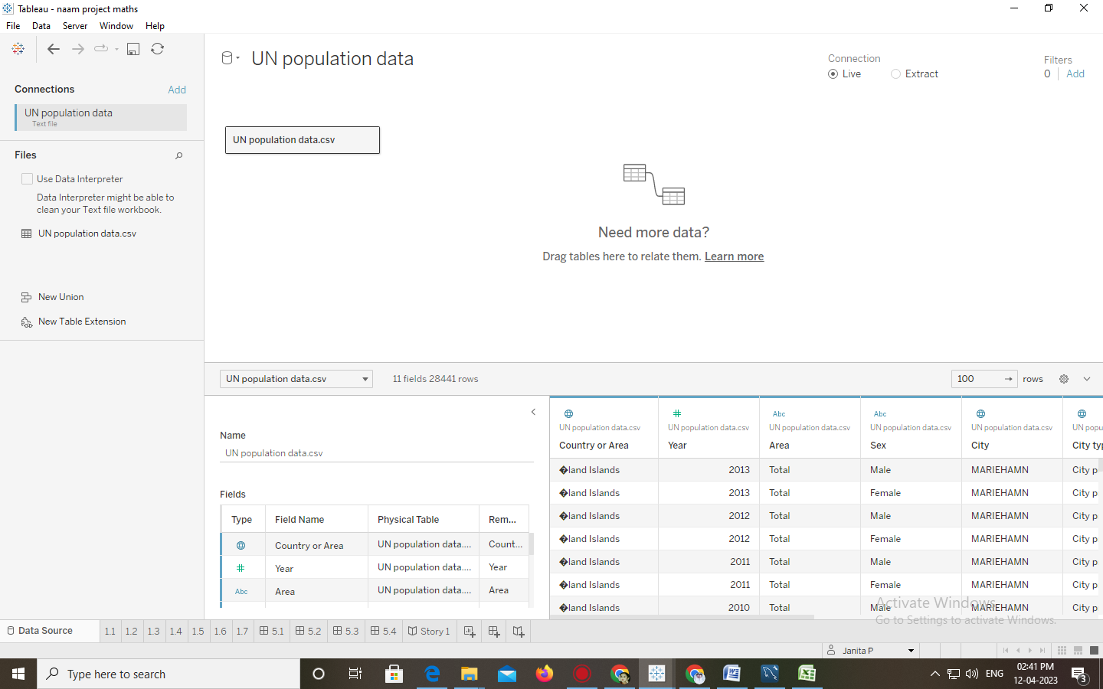

Milestone 3: Data Preparation

Activity 1: Prepare the Data for Visualization

Preparing the data for visualization involves cleaning the data to remove irrelevant or missing data, transforming the data into a format that can be easily visualized, exploring the data to identify patterns and trends, filtering the data to focus on specific subsets of data, preparing the data for visualization software, and ensuring the data is accurate and complete. This process helps to make the data easily understandable and ready for creating visualizations to gain insights into our analysis.

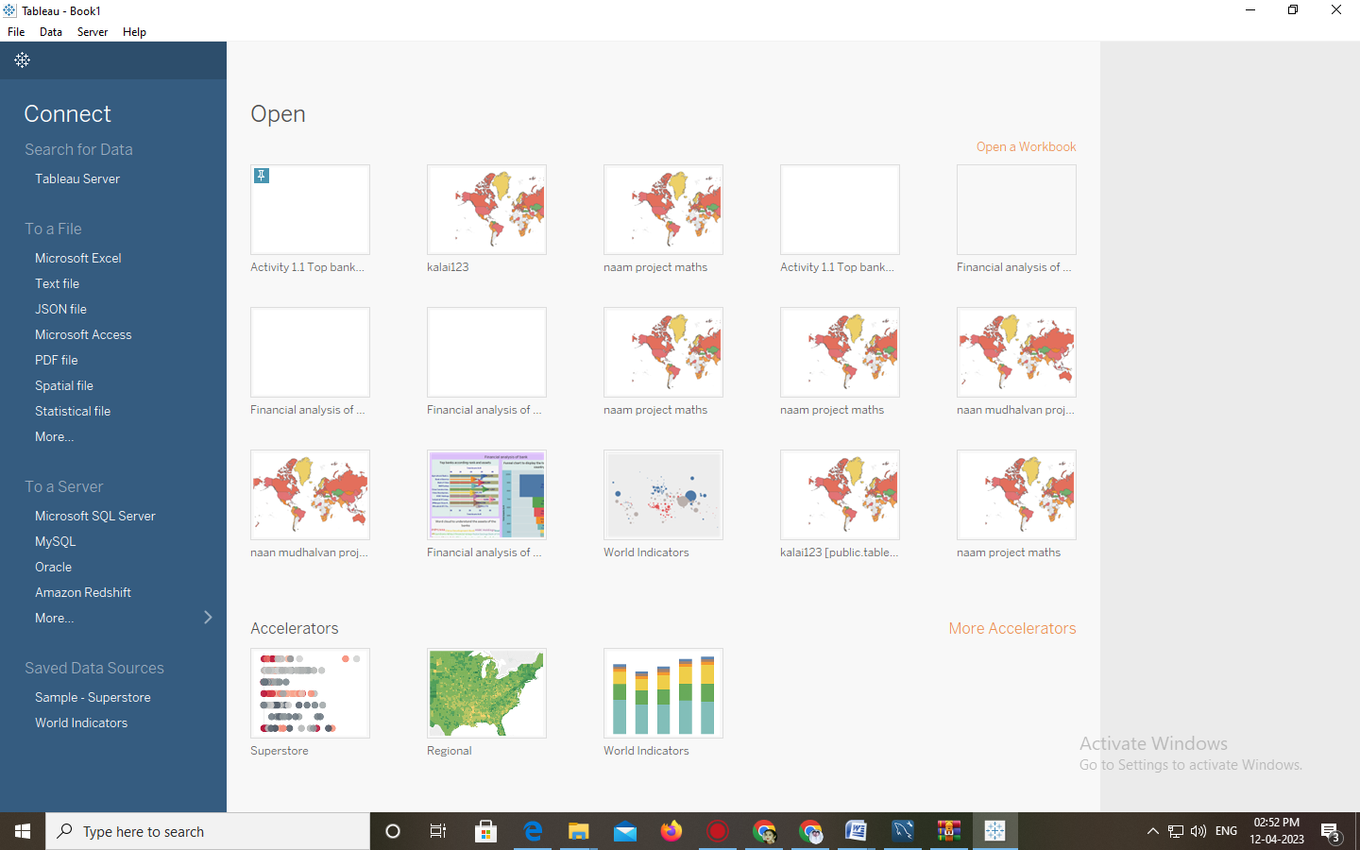

Milestone 4:

Data Visualization Data visualization is the process of creating graphical representations of data in order to help people understand and explore the information. The goal of data visualization is to make complex data sets more accessible, intuitive, and easier to interpret. By using visual elements such as charts, graphs, and maps, data visualizations can help people quickly identify patterns, trends, and outliers in the data.

Activity 1 No of Unique Visualizations

The number of unique visualizations that can be created with a given dataset. Some common types of visualizations that can be used to analyze the population growth in the cities, include bar charts, line charts, heat maps, scatter plots, pie charts,Maps etc. These visualizations can be used to compare performance, track changes over time, show distribution, and relationships between variables

Activity 1.1: Population records by type of countries

**Explanation video link:**

[https://drive.google.com/file/d/18eZJD4Xkr0Cd1OPCg4fXV2j9m5AJTlyx/view?usp=share_link](https://drive.google.com/file/d/18eZJD4Xkr0Cd1OPCg4fXV2j9m5AJTlyx/view?usp=share_link%20)

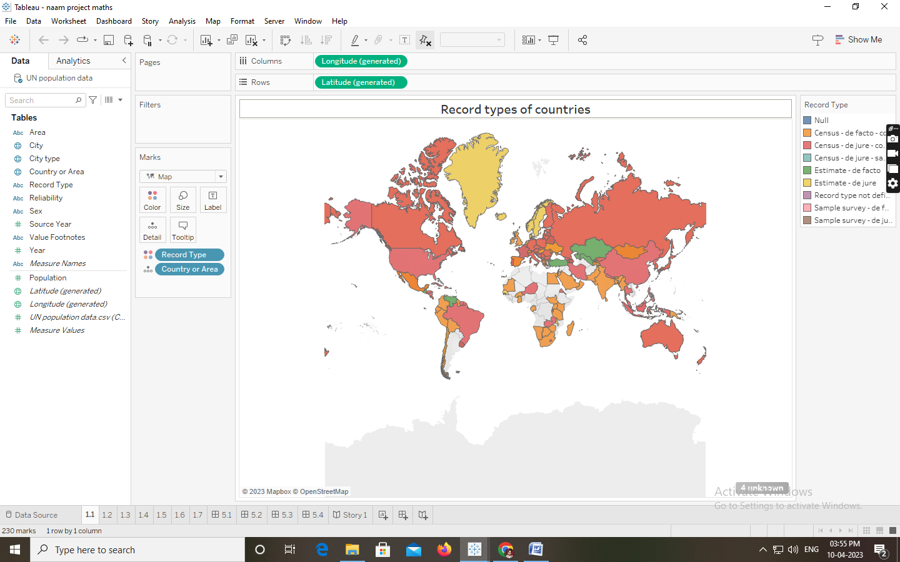

Activity 1.2: Population trends over the years

**Explanation video link:**

<https://drive.google.com/file/d/1qNvsp6tLQTG1KaZU7XeM6oya8vehHEvU/view?usp=share_link>

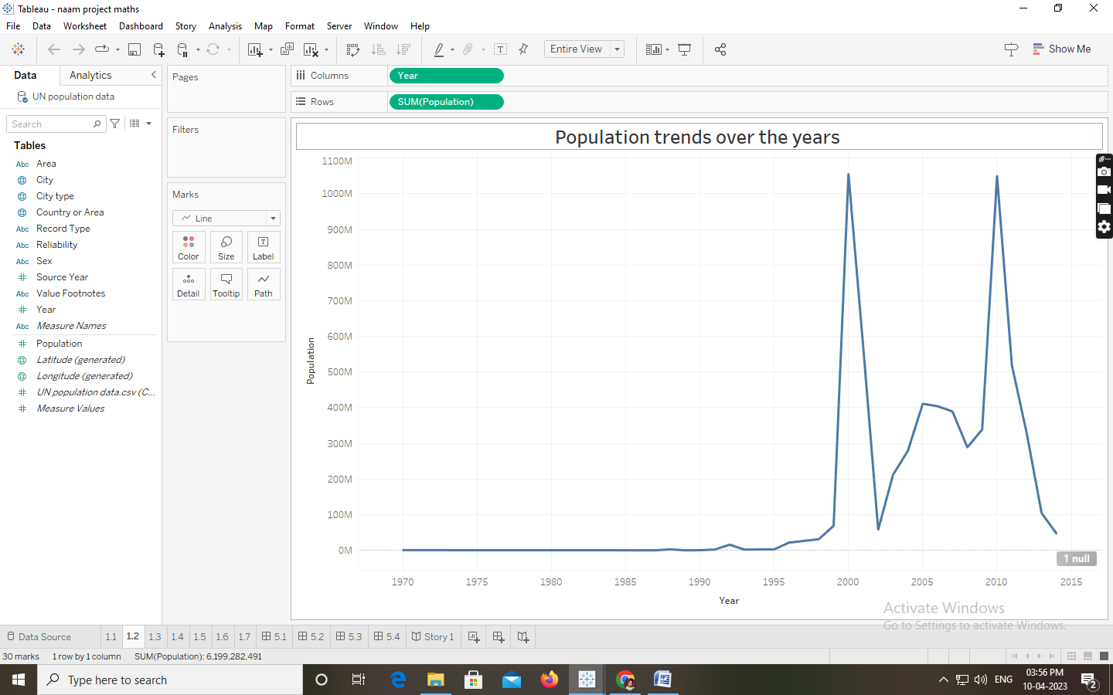

Activity 1.3: Population trends over the years by sex

**Explanation video link:**

[https://drive.google.com/file/d/1hw1uL02MBM5Us8umvV725_K4Z7XHN0fr/view?usp=sha re_link](https://drive.google.com/file/d/1hw1uL02MBM5Us8umvV725_K4Z7XHN0fr/view?usp=sha%20re_link)

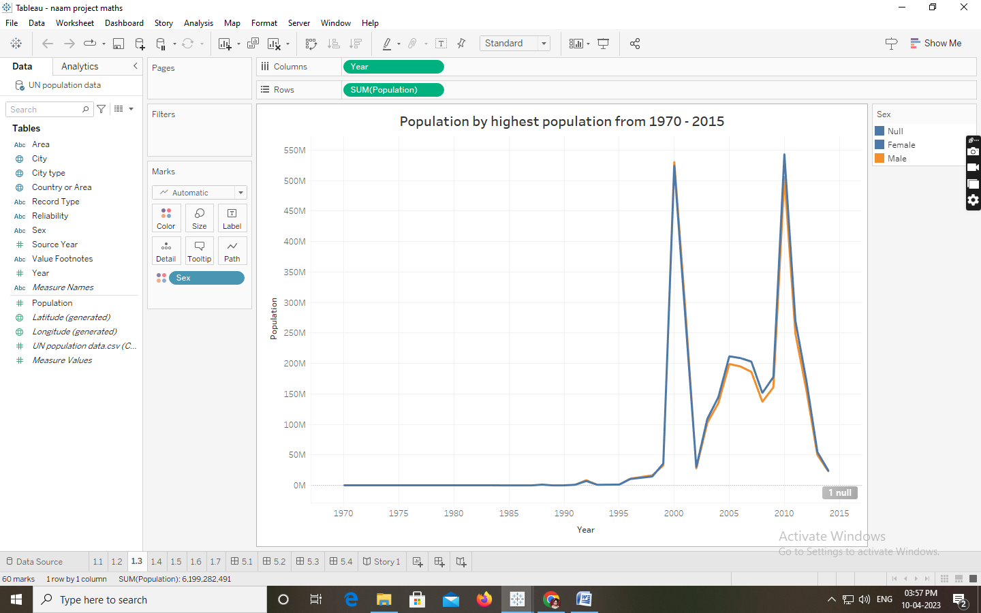

Activity 1.4: Cities with highest average populations

**Explanation video link:**

<https://drive.google.com/file/d/1ALi9nhNqDwONdMoglkiTKzU3xUY2CIH4/view?usp=share_link>

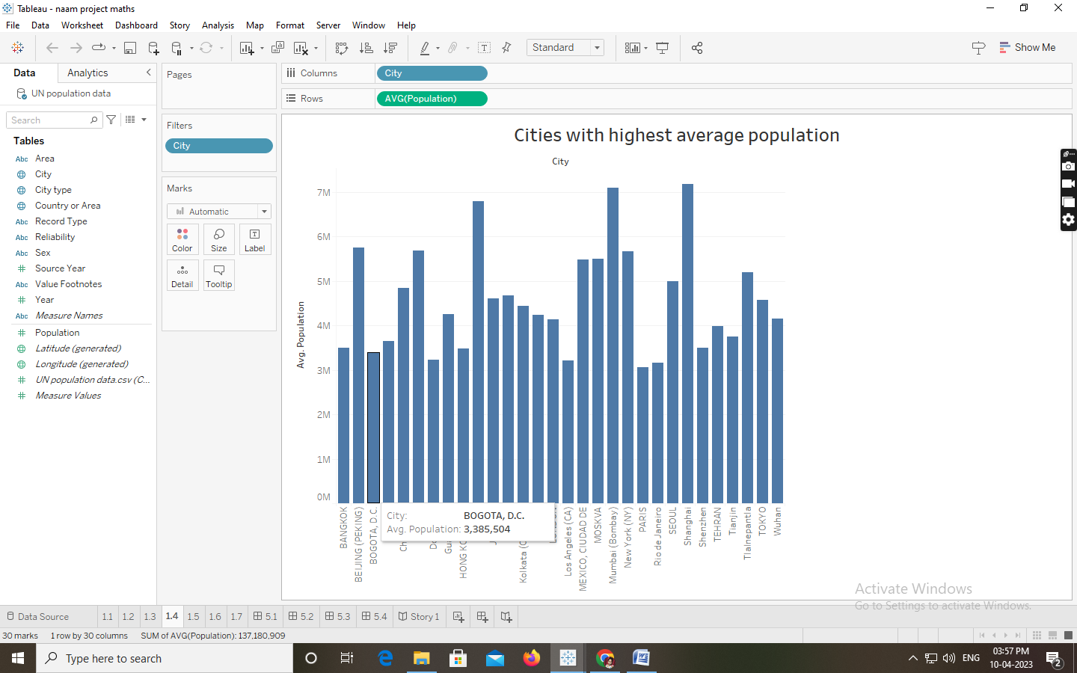

Activity 1.5: Countries with highest average population from 200-2014

**Explanation video link:**

<https://drive.google.com/file/d/1txARO5s9SKAh-5LnevRdrhkwgUISgXsk/view?usp=share_link>

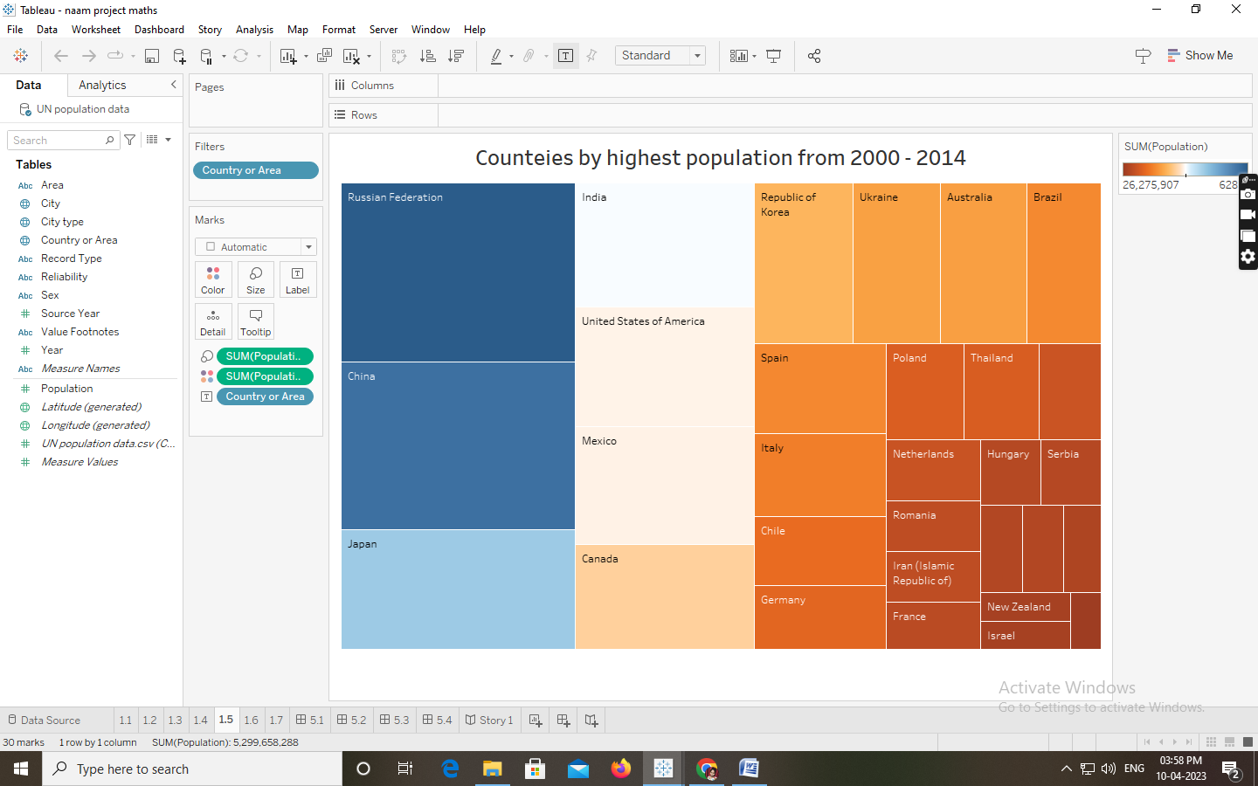

Activity 1.6: Population by city type

**Explanation video link:**

<https://drive.google.com/file/d/1kp44ar5-7g7HqtQ5GIRdyRFW7VqwKr_V/view?usp=share_link>

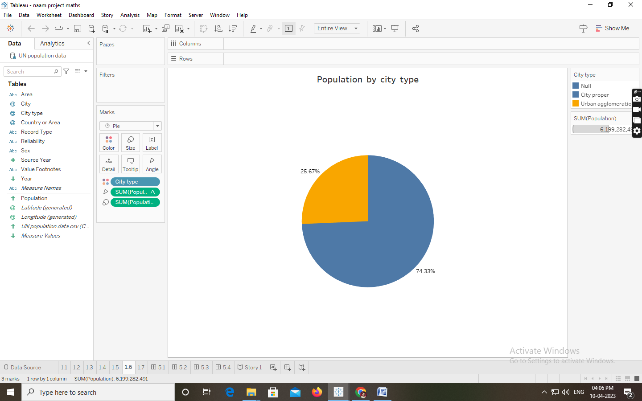

Activity 1.7: Population of citied by year

**Explanation video link:**

<https://drive.google.com/file/d/1d5HRSXJmnf5DEtl1Vh7l71MNHN4InLKr/view?usp=share_lin>

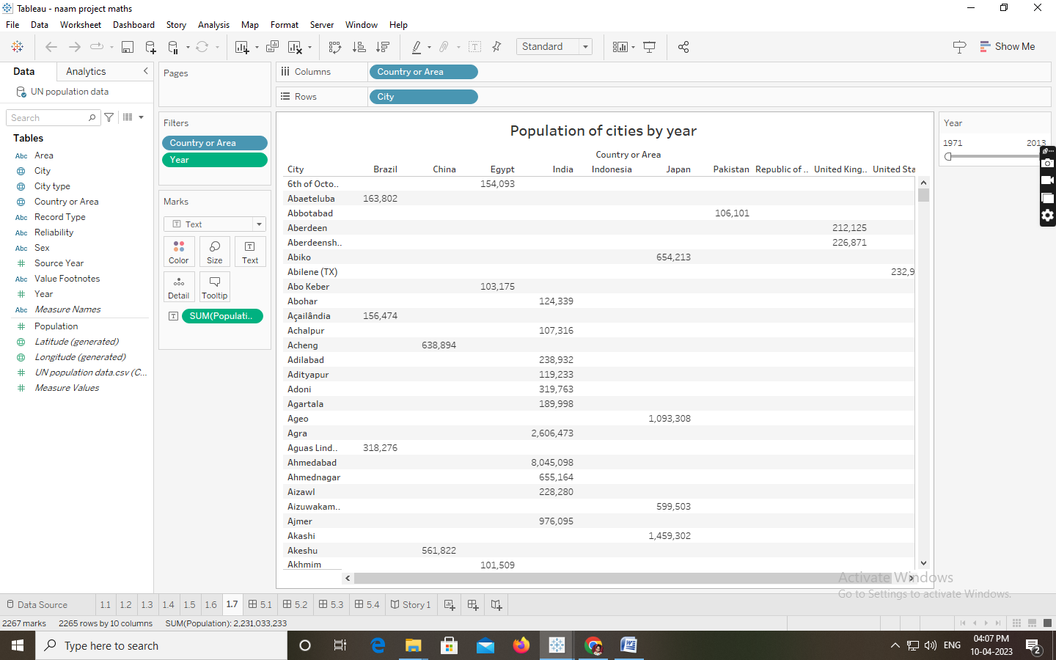

Milestone 5: Dashboard

A dashboard is a graphical user interface (GUI) that displays information and data in an organized, easy-to-read format. Dashboards are often used to provide real-time monitoring and analysis of data, and are typically designed for a specific purpose or use case. Dashboards can be used in a variety of settings, such as business, finance, manufacturing, healthcare, and many other industries. They can be used to track key performance indicators (KPIs), monitor performance metrics, and display data in the form of charts, graphs, and tables.

Activity :1- Responsive and Design of Dashboard

The responsiveness and design of a dashboard for analyzing population growth in the cities is crucial to ensure that the information is easily understandable and actionable. Key considerations for designing a responsive and effective dashboard include user-centered design, clear and concise information, interactivity, data-driven approach, accessibility, customization, and security. The goal is to create a dashboard that is user-friendly, interactive, and data-driven, providing actionable insights on the population demographics of different cities across the world Once you have created views on different sheets in Tableau, you can pull them into a dashboard.

Explanation video link:

<https://drive.google.com/file/d/1NfA20JXwSveCVwxUEBQd9b7Gc5sUuziT/view?usp=share_link>

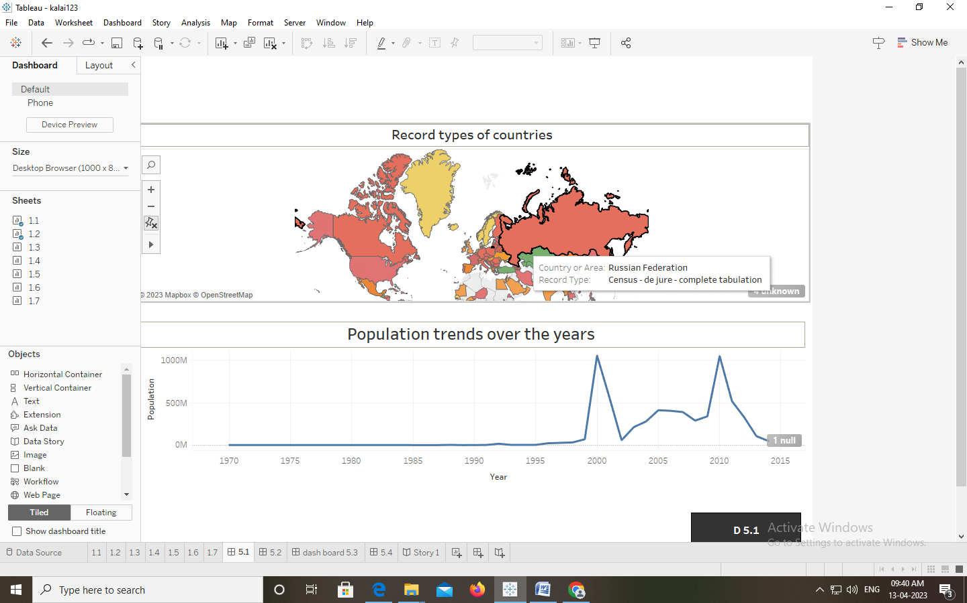

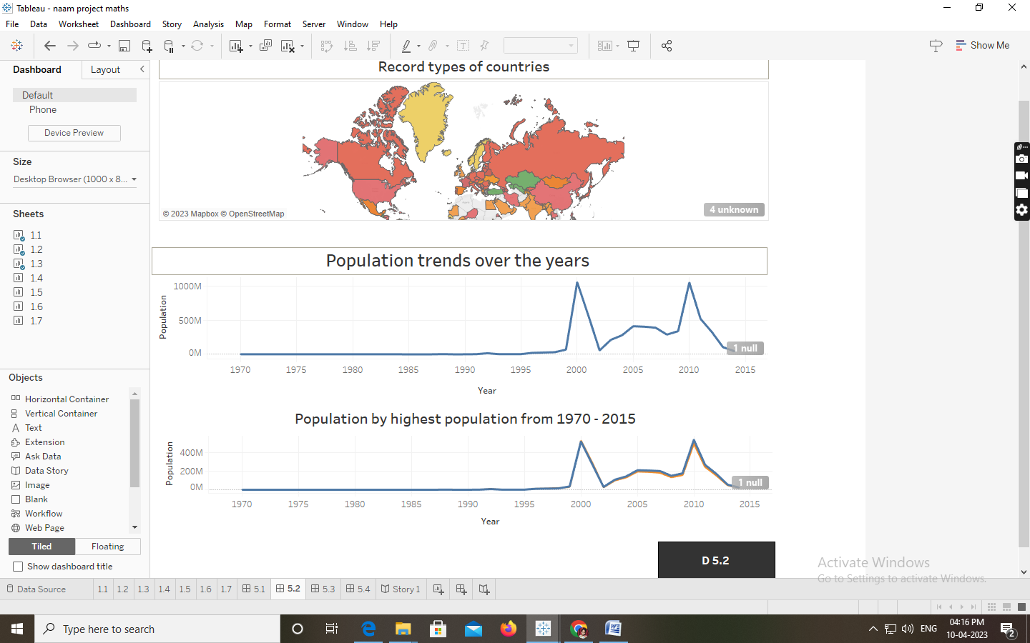

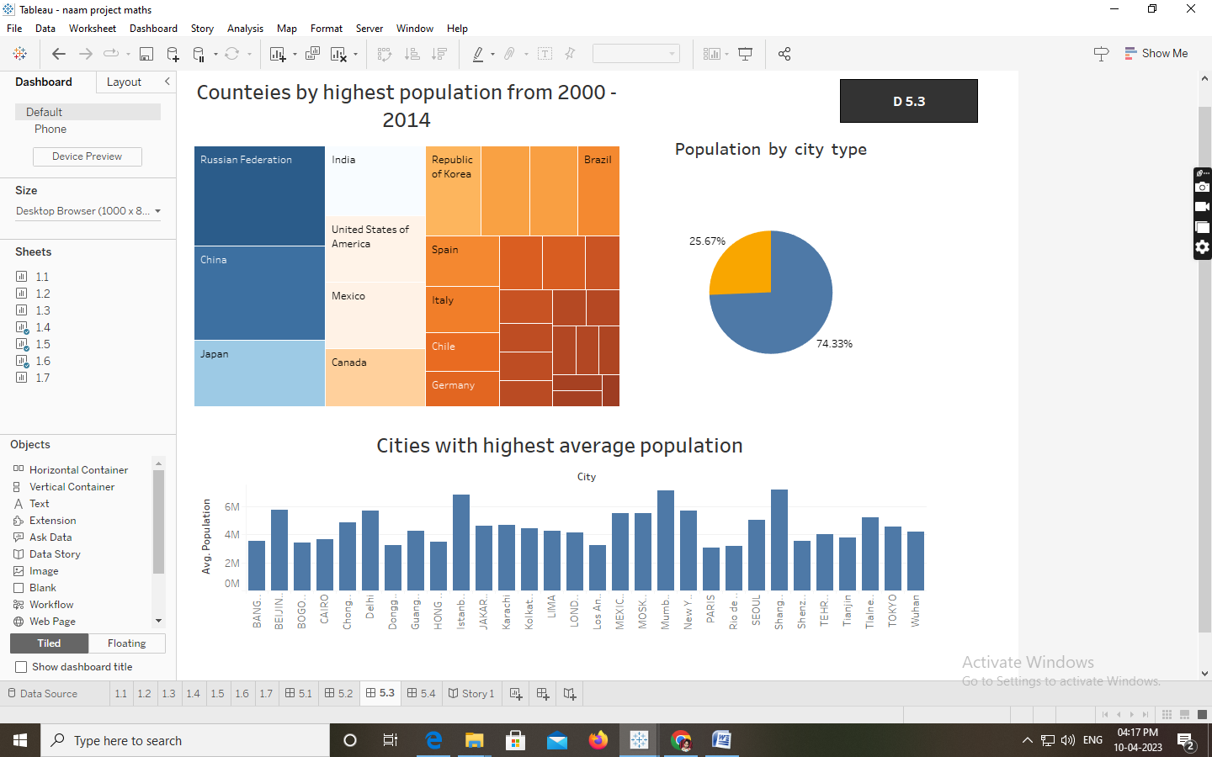

Milestone 6: Story

A data story is a way of presenting data and analysis in a narrative format, with the goal of making the information more engaging and easier to understand. A data story typically includes a clear introduction that sets the stage and explains the context for the data, a body that presents the data and analysis in a logical and systematic way, and a conclusion that summarizes the key findings and highlights their implications. Data stories can be told using a variety of mediums, such as reports, presentations, interactive visualizations, and videos.

Activity:1- No of Scenes of Story

The number of scenes in a storyboard for a data visualization analysis of population growth across the cities ,will depend on the complexity of the analysis and the specific insights that are trying to be conveyed. A storyboard is a visual representation of the data analysis process and it breaks down the analysis into a series of steps or scenes.

Explanation video link:

<https://drive.google.com/file/d/1RgEatbDQ4_UxGtonCNRUz0qbhwImykc1/view?usp=share_link>

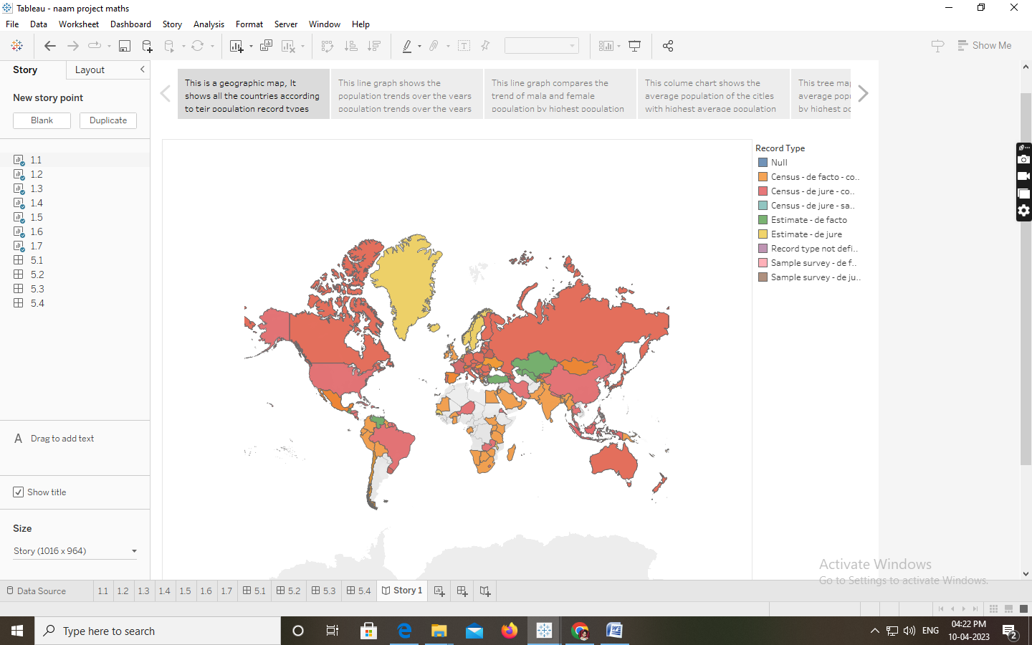

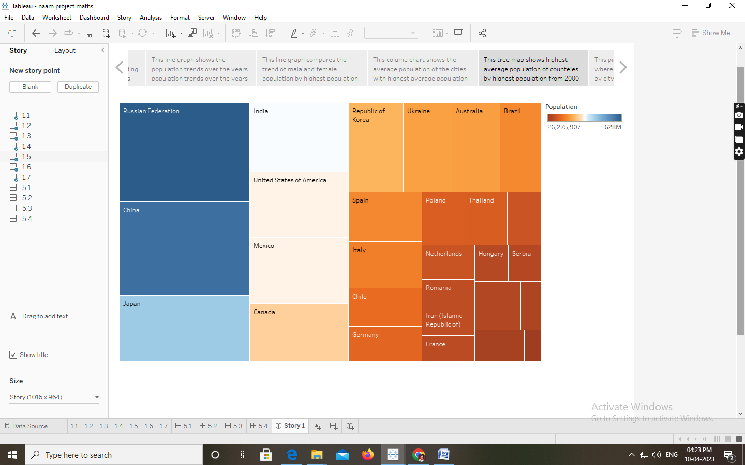

Milestone 7: Performance Testing

Activity 1: Amount of Data Rendered to DB

● The amount of data that is rendered to a database depends on the size of the dataset and the capacity of the database to store and retrieve data.

● Open the MySQL Workbench, go to the database then click to expand the tables, select the table and click on (i) button to get the information related to table such as column count, table rows etc.

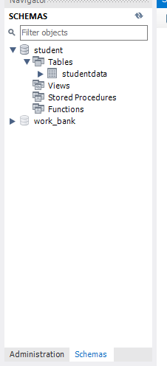

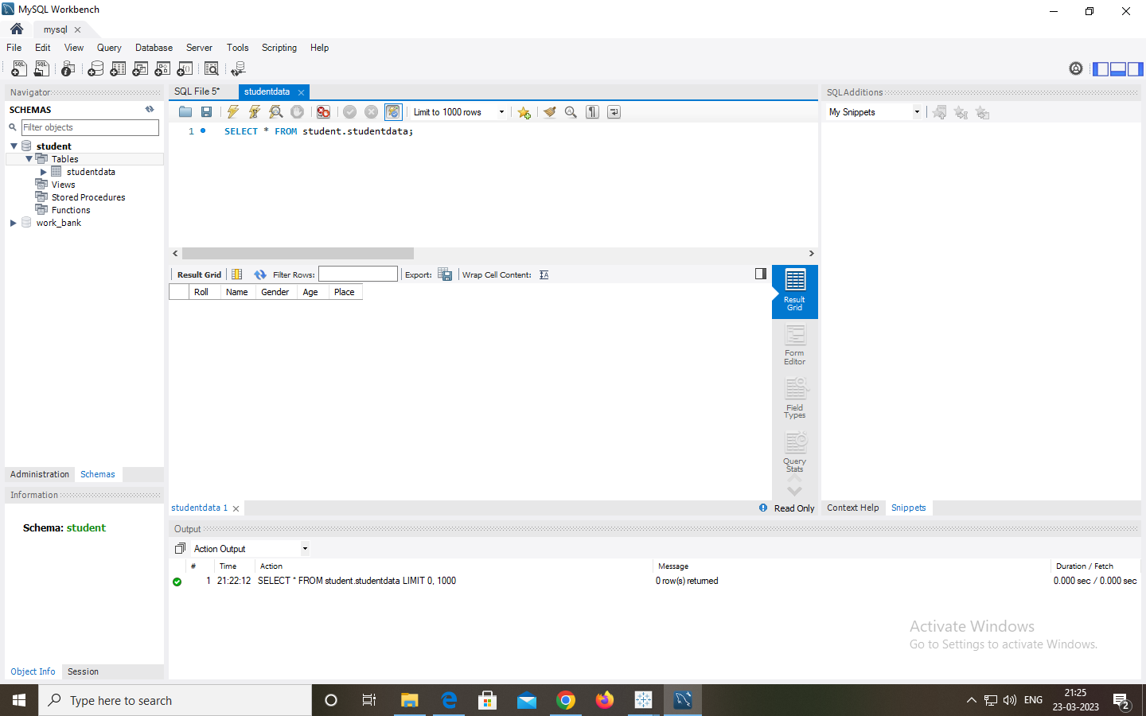

The amount of data that is rendered to a database depends on the size of the dataset and the capacity of the database to store and retrieve data with the help of the schemas in MySQL Workbench.

Activity 2: Utilization of Data Filters

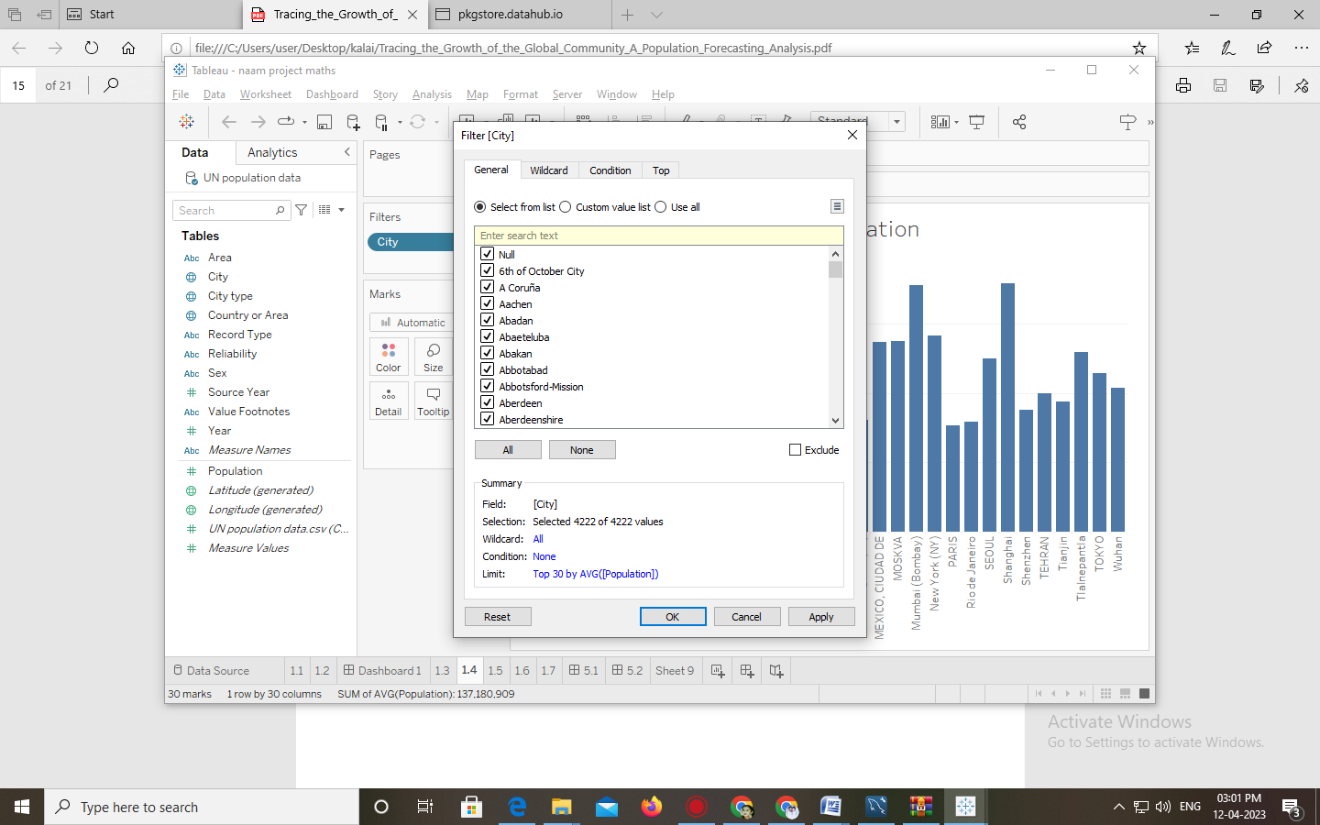

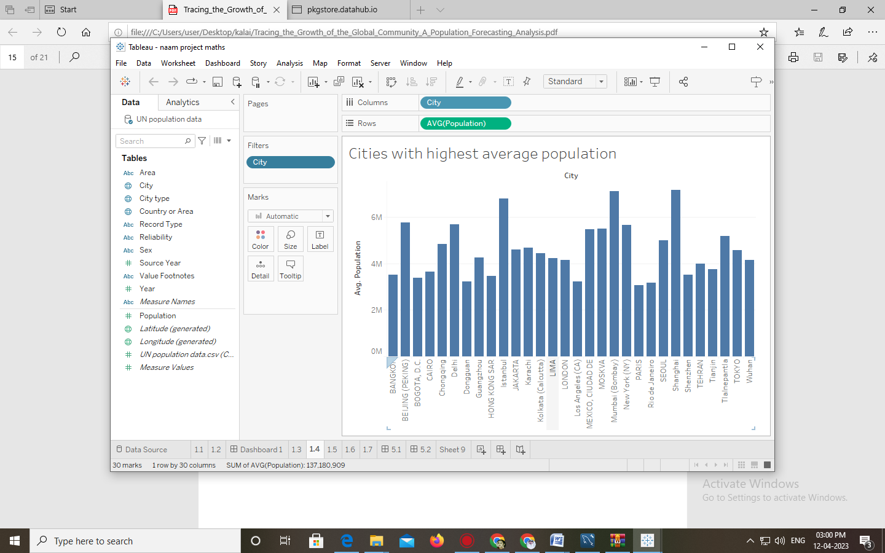

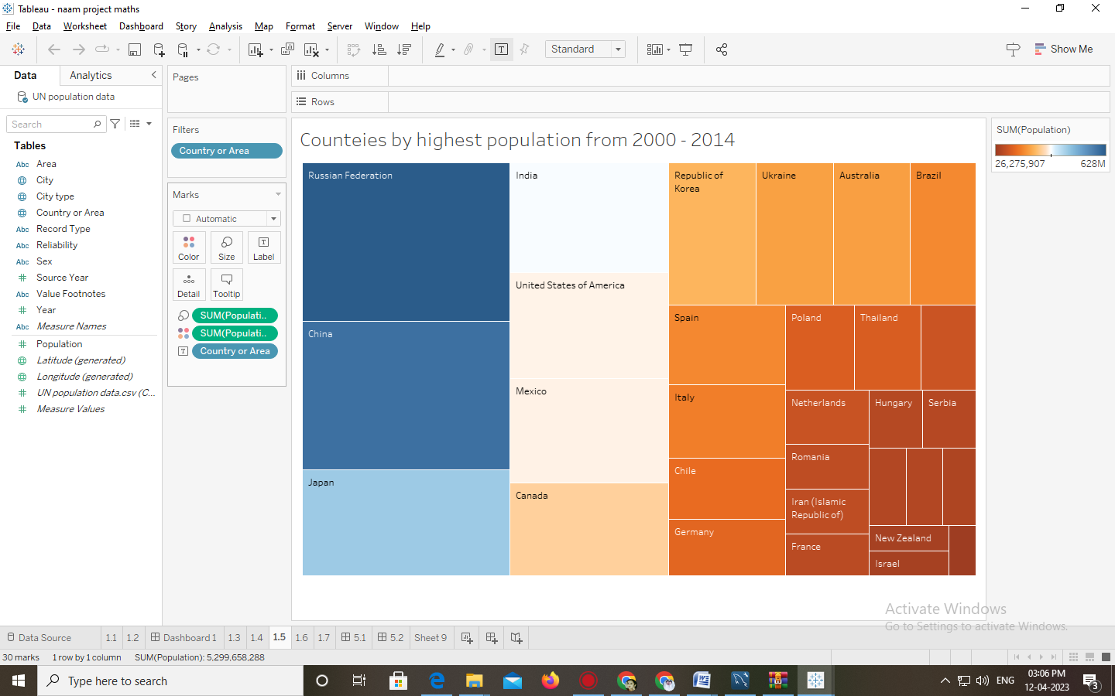

Activity 3: No of Calculation Fields



Milestone 8:

Web integration Publishing helps us to track and monitor key performance metrics, to communicate results and progress. help a publisher stay informed, make better decisions, and communicate their performance to others. Publishing dashboard and reports to tableau public Step 1: Go to Dashboard/story, click on share button on the top ribbon

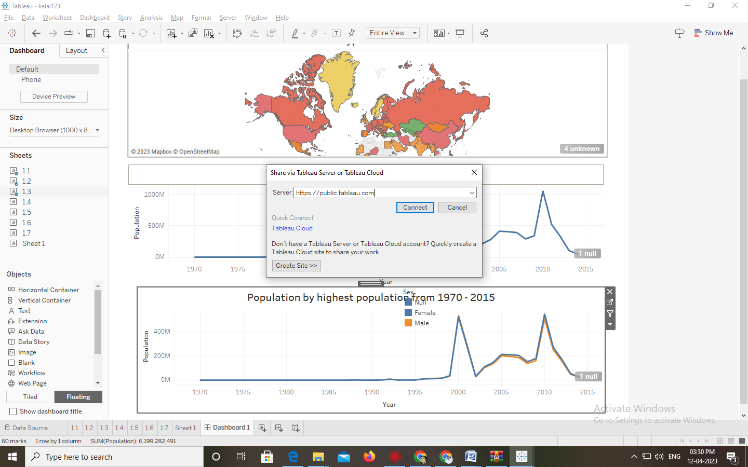

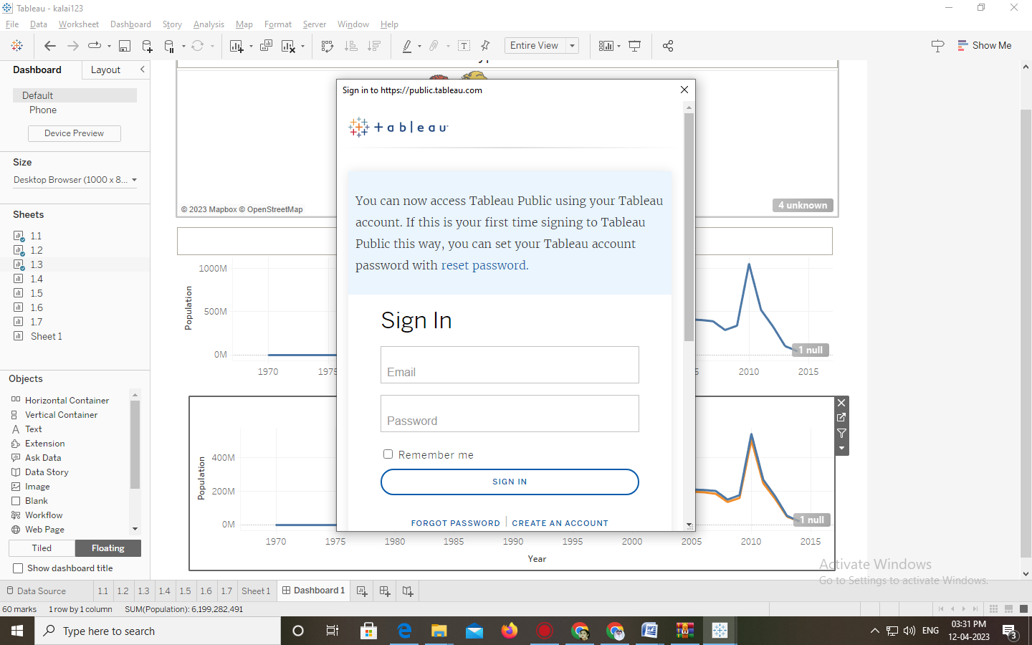

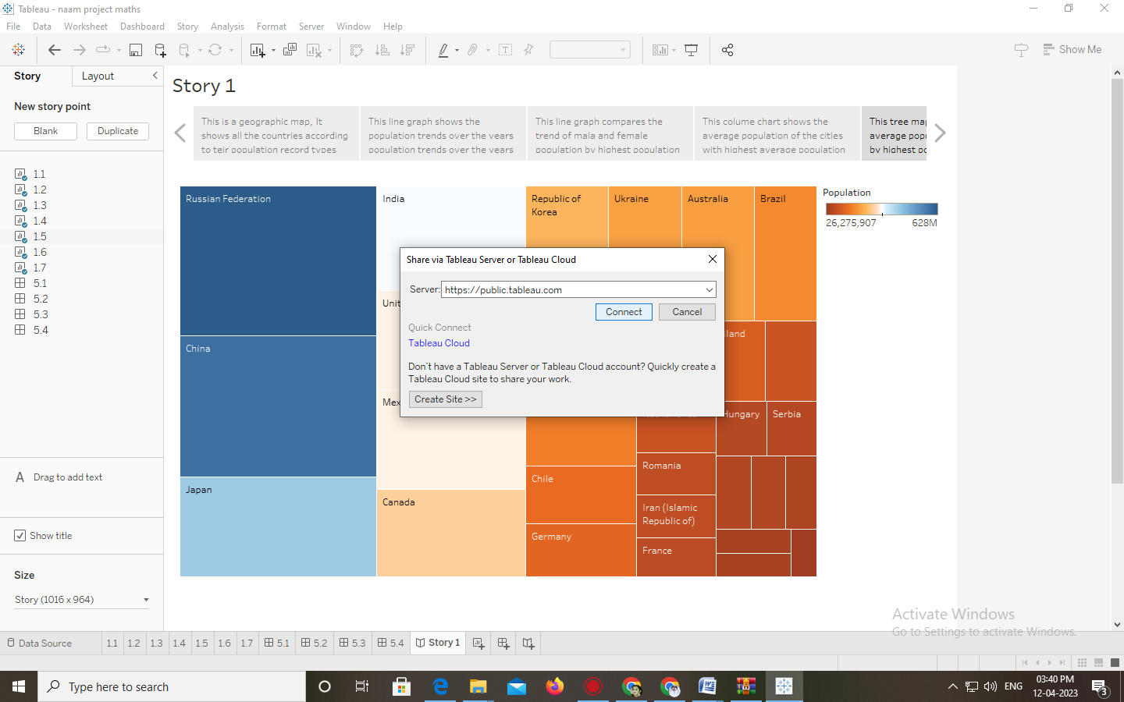

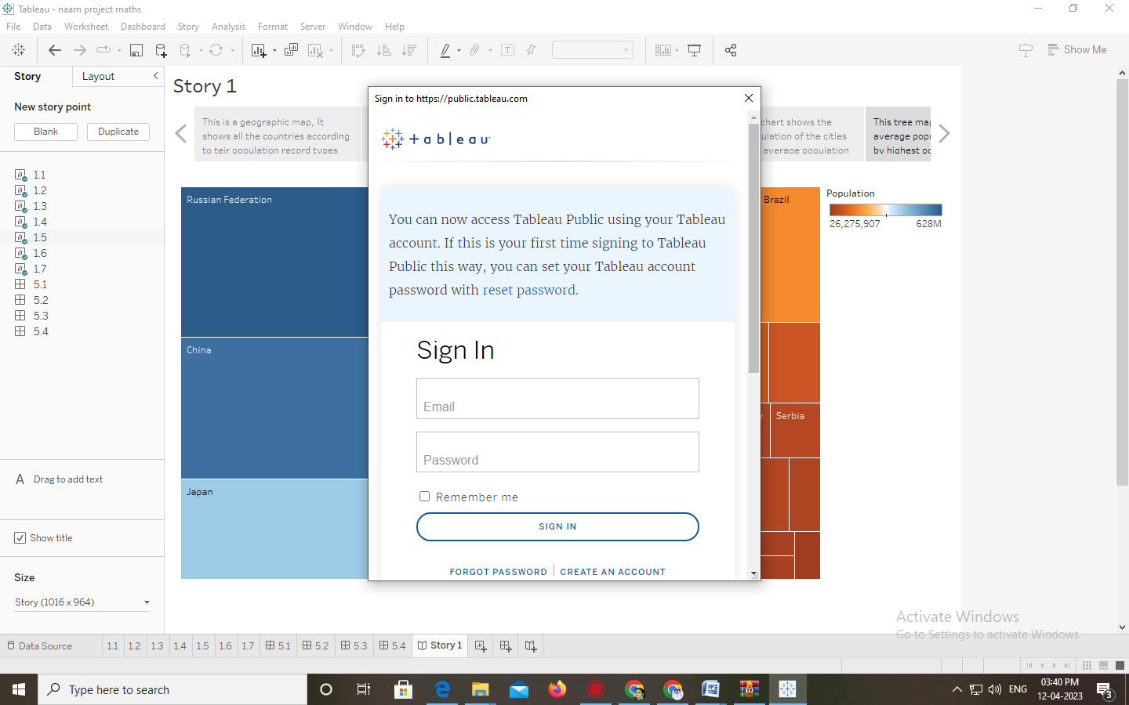

Give the server address of your tableau public account and click on connect. Explanation Video:<https://drive.google.com/file/d/1jCi8LAZPlQGNhFXCgUWcwNxbQLj8wdS-/view?usp=share_link>.

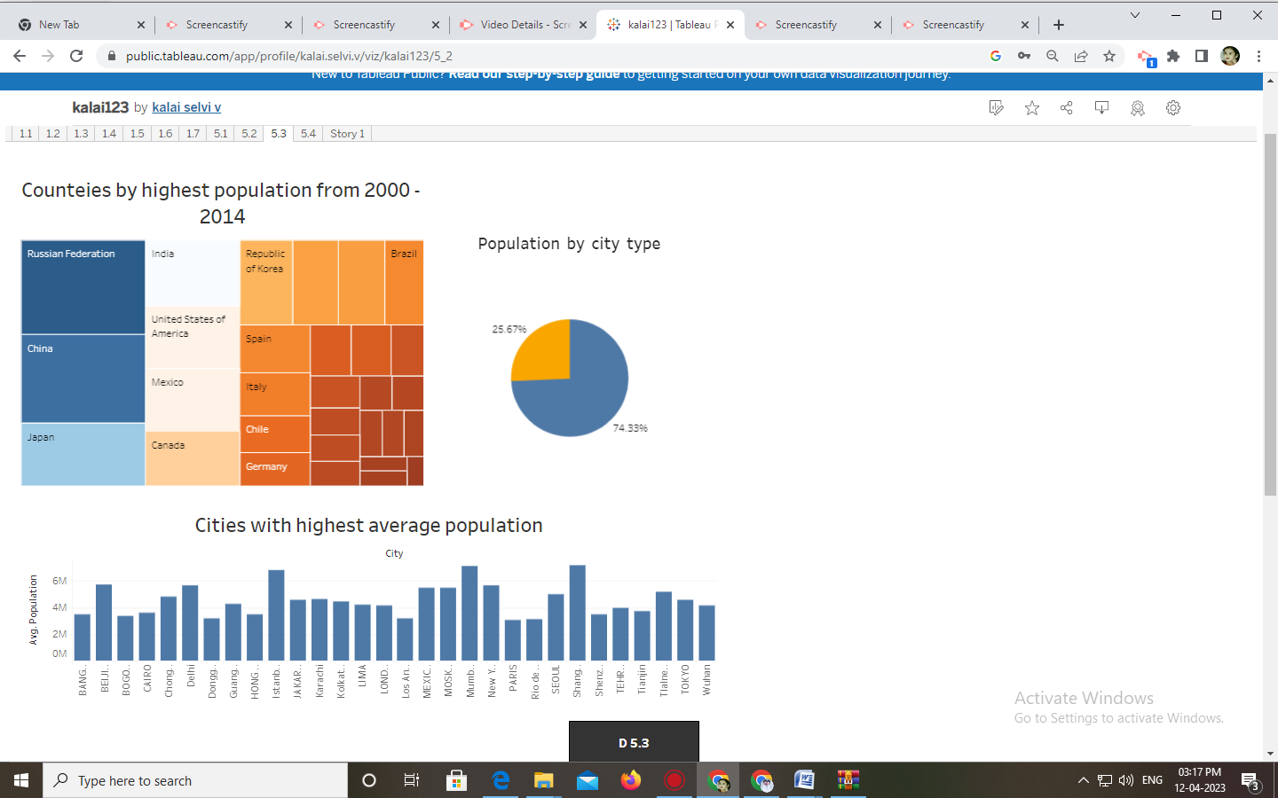

Advantages and disadvantages:

Advantages :

* **Data visualization.**
* **Quickly Create Interactive visualizations.**
* **Ease of Implementation.**
* **Tableau can handle large amounts of data.**
* **Use of other scripting languages in Tableau**
* **Mobile Support and Responsive Dashboard**
* **Tableau Company Strategy**
* In Tableau there is an option where the user can make “live” to connections to different data sources like SQL etc.,

Disadvantages:

* **Scheduling or notification of reports**
* **No Custom Visual Imports**.
* **Custom formatting in Tableau**.
* **Static and single value parameters**
* **Screen Resolution on Tableau Dashboards**
* **Limited Data Preprocessing**
* **Scaling and Pricing for Enterprise**
* Therefore, there is always some manual effort required when users need to update the data in the back-end.
* Tableau is not a complete open tool.
* Unlike other tools developers can create custom visuals that can be easily imported Tableau.

Applications :

* Tableau is greatly used because data can be analyzed very quickly with it.
* The visualizations are generated as dashboards and worksheets.
* Tableau allows one to [create dashboards](https://intellipaat.com/blog/tutorial/tableau-tutorial/creating-dashboards/) that provide actionable insights and drive the business forward.
* Tableau products always operate in virtualized environments when they are configured with the proper underlying operating system and hardware.
* Tableau is [used by data scientists](https://intellipaat.com/blog/tableau-data-science/) to explore data with limitless visual analytics.

Conclusion :

In this project, we learnt different ways to create calculated fields in Tableau as well as different types of calculated fields and plotting the appropriate graph. Our data sources will not have all the possible fields we want to use in our analysis. Calculated fields allow us to derive values based on logic and expressions; they ultimately add more flexibility and drive more insights into our Tableau dashboards.

Future Scope :

* A tableau is a powerful tool for data visualization and analysis. Data analysts can use the tool to create valuable reports that help them make intelligent decisions quickly and easily.
* Creating data visuals immediately and switching among the types to easily find the model that suits your data.
* A wide range of choice is there in selecting the models to represent the data.
* Data representation can be done by selecting any form in which you want to showcase it i.e. by graphics, tables, maps etc.
* Even the beginner can come up with the acceptable visual appearances.
* The user interface is well designed to customize the view within a few clicks versus various views.
* It’s simple and supple execution allows the user to customize and represent the data with the help of menus enclosing several options.
* Learning tableau enhances the growth of any organization by scrutinizing its data in an appropriate way and analyzing the reasons for the drawback of the organization/business.
* Within a short period of time, one can gain expertise and implement the same at their workplace